**Java Postfix Converter**

Kyle D. Musegades, Jr.

Colorado State University Global

CSC400-1 Data Structures and Algorithms

Dr. Shaher Daoud

November 5, 2023

**Java Postfix Converter**

**Program Output and Execution Screenshot**

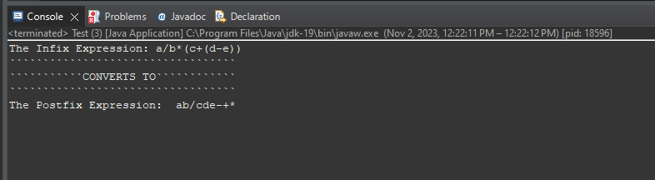

**Program Source Code Screenshots (also included full source code in separate file)**

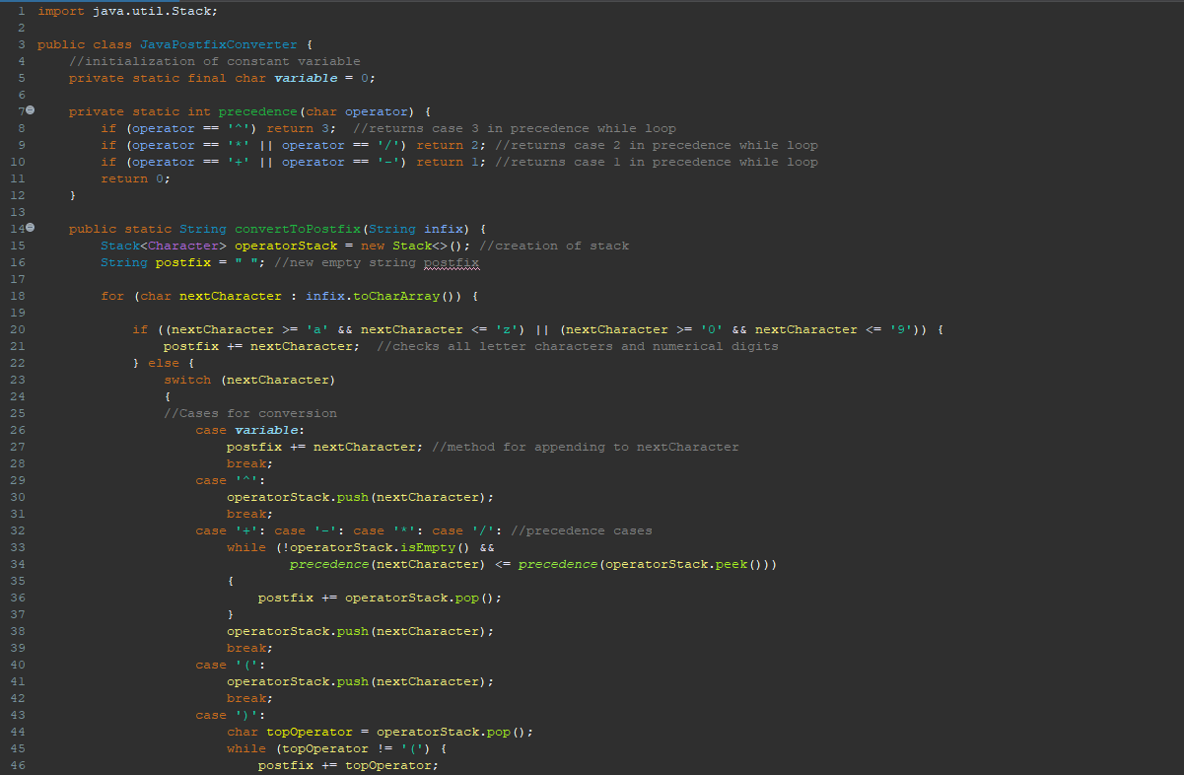

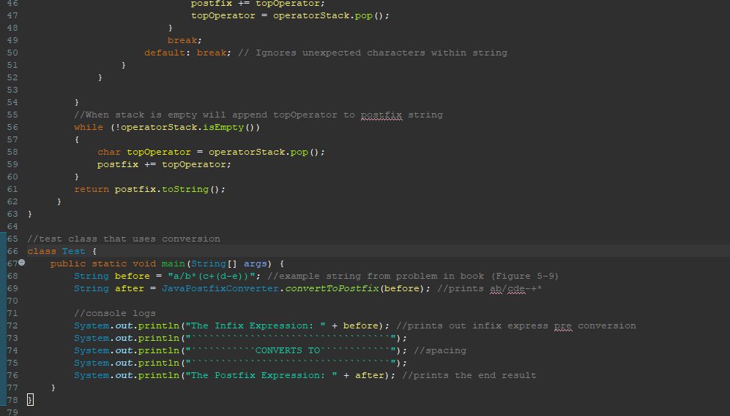

**References**

Carrano, F. M., & Henry, T. (2019). *Data structures and abstractions with Java* (5th ed.). Pearson Education, Inc.